Facility address | Romiley Cricket Club  Birchvale Drive  Romiley  Stockport  Cheshire  SK6 4LD
 | Description of location | W3W
What3Words location | Main entrance | Installs.dolls.trek
Defibrillator | On car park side of score box / for code ring 999
Hospital(s) | Stepping Hill, Poplar Grove, Hazel Grove, Stockport SK2 7JE
Medication | All individual conditions should be kept on record by coaches and administrators in case of emergency
First aid kit | Each team should have their own individual first aid kit. They are also located behind both bars and in the changing rooms.
Accident/incident report book | All coaches and captains should log/report their own incidents.

Things to consider in a serious incident:

- If a junior game: children to be taken to changing rooms (out of view of the incident).
- Ensure emergency services are given the address details including the W3W location.
- People to be sent Birchvale Drive entrance to help direct the Ambulance.
- Send someone for the defibrillator.
- If CPR is required three people to be nominated to perform chest compressions and breaths:
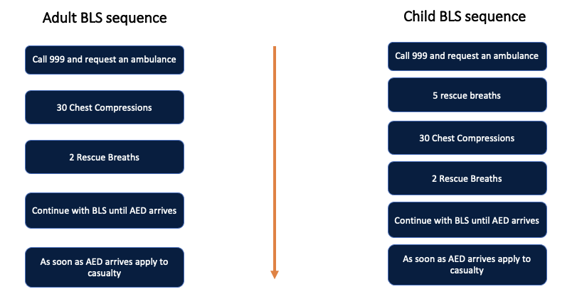
PLEASE NOTE THAT MOUTH TO MOUTH IS OPTIONAL

